**CONTENTS**

**TRAINING 6** 2

**KẾT QUẢ TRAINING 6** 2

**TRAINING 7** 2

**KẾT QUẢ TRAINING 7** 2

# 

# **TRAINING 6**

## **KẾT QUẢ TRAINING 6**

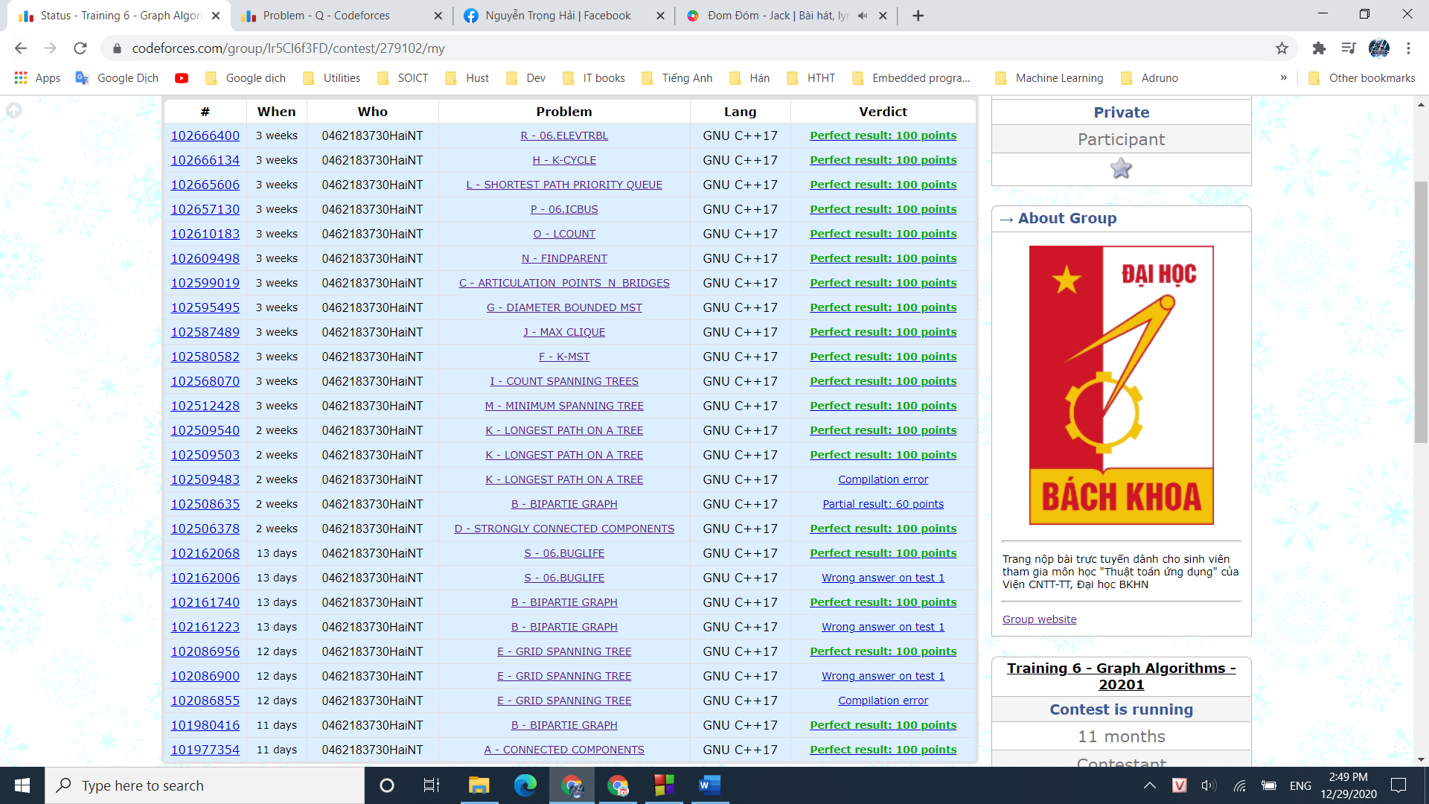

# **TRAINING 7**

## **KẾT QUẢ TRAINING 7**

